**The jClass Designer**

**Software Design Description**

**Author:** Daniel Khuu

Richard McKenna

Debugging Enterprises

March 2016

Version 1.01

**Abstract:** This document describes the software design for the jClass Designer, an application used to produce UML diagrams for Java dynamically.

**Based on IEEE Std 1016-2009 document format**

©2016 Debugging Enterprises

©Debugging Enterprises/CSE 219 Spring 2016•Project jClass Designer

**1 Introduction**

The jClass Designer application is a modeling tool to create UML (Unified Modeling Language) class diagrams, which is the primary structural design format for Object-Oriented software development. The program will also export the diagrams into Java skeleton code, like .java files, to make the application more useful to Java developers.

* 1. **Purpose**

This document is to serve as the blueprint for the construction of the jClass Designer application. This design will use UML diagrams to provide complete detail regarding all packages, classes, instance variables, class variables, and method signatures needed to build the application. In addition, UML Sequence diagrams will be used to specify object interactions post-initialization of the application, meaning in response to user interactions or timed events.

* 1. **Scope**

The jClass Designer application will be used by Java developers to design software. Therefore, it’s important to provide features that software designers look for in projects in a user-friendly manner. To do this, the user interface must be organized and attractive to use. In addition, it’s important that in the next stage i.e. software design, we make sound software design decisions such that the application can be easily extended. The plan is for this application to improve its usability over time for its users. As such, a framework called the AppFramework, will be designed along with the jClass Designer to provide an easy-to-use toolbar. So, the design contains design descriptions for the development of the framework and application. Note that Java is the target language for this design software.

* 1. **Definitions, acronyms, and abbreviations**

**Framework** – In an object-oriented language, a collection of classes and interfaces that collectively provide a service for building applications or additional frameworks all with a common need.

**GUI** – Graphical User Interface, visual controls like buttons inside a window in a software application that collectively allow the user to operate the program.

**IEEE** – Institute of Electric and Electronics Engineers, the “world’s largest professional association for the advancement of technology”.

**UML** – Unified Modeling Language, a standard set of document formats for designing software graphically.

**UML Use Case Diagram** – A UML document format that specifies how a user will interact with a system. Note that these diagrams do not include technical details. Instead, they are fed as input into the design stage (stage after this one) where the appropriate software designs are constructed based in part on the Use Cases specified in the SRS.

**UML Class Diagram** – A UML document format that specifies the structural design of an object-oriented software system.

**UML Sequence Design** – A UML document format that specifies the dynamic design of a software system.

* 1. **References**

**IEEE Std 830TM-1998 (R2009)** – IEEE Recommended Practice for Software Requirements Specification

**Wikipedia** – Provides adequate definitions for **UML Diagrams.**

* 1. **Overview**

This Software Design Description document provides a working design for the jClass Designer software application. Note that all parties in the implementation stage must agree upon all connections between components before proceeding with the implementation stage. Section 2 of this document will provide the context for the project and specify all the conceptual design. Section 3 will present what user interface controls are needed and all program functionality. Section 4 provides a Table of Contents, an Index, and References.

1. **Package-Level Design Viewpoint**

As mentioned, this design will encompass both the jClass Designer application and the AppFramework to be used in its construction. In building both we will heavily rely on the Java API to provide services. The following are descriptions of the components to be built, as well as how the Java API will be used to build them.

* 1. **The jClass Designer and AppFramework Overview**

The jClass Designer and the App Framework will be designed and developed in tandem. Figure 2.1 specifies all the components to be developed and places all classes in home packages.

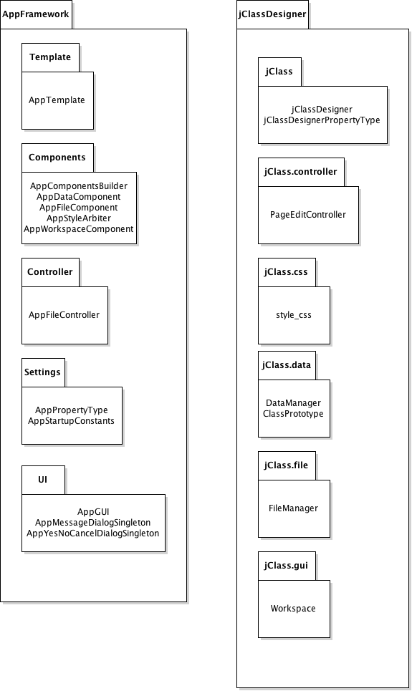

**Figure 2.1: Design Packages Overview**

* 1. **Java API Usages**

Both the framework and the jClass Designer application will be developed using the Java programming languages. As such, this design will make use of the classes specified in Figure 2.2. 

**Figure 2.2: Java API Classes and Packages To Be Used**

**2.3: Java API Usage Descriptions**

The following tables below summarize hoe each of these classes will be used.

|  |  |
| --- | --- |
| Class/Interface | Use |
| Event | Basic class for JavaFX events. |
| EventHandler | For setting the action of buttons and check boxes in the application. |

**Table 2.1: Uses for classes in the Java API’s javafx.event package**

|  |  |
| --- | --- |
| Class/Interface | Use |
| MouseEvent | For users to interact with the application by using the mouse. |
| KeyEvent | For users to interact with the application with the keyboard. |

**Table 2.2: Uses for classes in the Java API’s javafx.scene.input package**

|  |  |
| --- | --- |
| Class/Interface | Use |
| Image | To load the image icons of the application. |
| ImageView | To allow the image icons to resize if necessary. |
| WriteableImage | For exporting the design renderer into a photo. |

**Table 2.3: Uses for classes in the Java API’s javafx.scene.image package**

|  |  |
| --- | --- |
| Class/Interface | Use |
| JsonArray | An array to save the class diagrams into a json file. |
| JsonArrayBuilder | For building an array to store the class diagrams of the application into a json file. |
| JsonObject | An object to save into a json file directly or by saving through a JsonArray. |
| JsonObjectBuilder | For making our individual class diagrams into an object to save into a JsonArray. |
| JsonReader | For loading the json file into the application from its saved state. |
| JsonWriter | Used to write the json file from the JsonObject or JsonArray. |
| JsonWriterFactory | Used to make the json format into a pretty format. |
| JsonGenerator | For our application to generate a json file. |

**Table 2.4: Uses for classes in the Java API’s javafx.json package**

|  |  |
| --- | --- |
| Class/Interface | Use |
| GridPane | For having our design renderer to have gridlines as specified in the specifications. |
| BorderPane | For making the UI of the workspace. |
| Pane | For making the UI of the workspace. |
| HBox | For making the UI of the workspace. |
| VBox | For making the UI of the workspace. |

**Table 2.5: Uses for classes in the Java API’s javafx.scene.layout package**

|  |  |
| --- | --- |
| Class/Interface | Use |
| TreeItem | To represent a single diagram of the tree. |
| TreeView | Provides a view of the root and children of the class diagrams. |
| Button | Provides buttons for the application. |
| Label | Provides labels for various components of the UI. |
| ScrollPane | Provides users to scroll down the renderer and the tables in the component toolbar. |
| SelectionMode | To get current values for a specified diagram. |
| SpiltPane | Provides possible scrolling between the design renderer pane and the component toolbar to a specified point. |
| Tooltip | Provides description of the buttons when hovered over. |
| TextField | Allows the user to input text into the class diagrams. |
| TextArea | Allows the diagrams to hold text. |
| Checkbox | Provides check boxes to allow for enable or disable certain features. |

**Table 2.6: Uses for classes in the Java API’s javafx.scene.control package**

|  |  |
| --- | --- |
| Class/Interface | Use |
| File | Provides representation of file and directory pathnames while saving, loading, and exporting. |
| FileInputStream | Will read the data from the json file and puts it all into a JsonArray so it could be loaded into the application. |
| FileOutputStream | Will be used to write the json file from the JsonArray or JsonObject, or to export the Java source code when the user wants to export code. |
| InputStream | A class to provide FileInputStream for our application to use. |
| OutputStream | A class to provide FileOutputStream for our application to use. |
| PrintWriter | Used to make our json file look pretty in print. |
| StringWriter | Makes a string from a string buffer of the Json file. |

**Table 2.7: Uses for classes in the Java API’s javafx.io package**

|  |  |
| --- | --- |
| Class/Interface | Use |
| launch | Launches the GUI application. |

**Table 2.8: Uses for classes in the Java API’s javafx.application.Application package**

|  |  |
| --- | --- |
| Class/Interface | Use |
| Shape | To create boxes and lines of the UML diagrams. |
| Rectangle | Provides a box to represent classes, methods, and interferes in the design renderer. |
| Triangle | Provides a triangle to symbolize relationships between classes, methods. and interferes in the design renderer. |
| Line | Provides a line to show relationships between classes, interferes, and methods. |
| Polygon | Provides additional shapes that could be used in the application. |

**Table 2.9: Uses for classes in the Java API’s javafx.scene.shape package**

|  |  |
| --- | --- |
| Class/Interface | Use |
| Scene | Provides a scene to show the content of the GUI to the user. |
| Cursor | Provides changes to the shape of the arrow when pressing certain buttons. |
| SnapshotParameters | Provides parameters of a photo when the user wants to export a photo of the design renderer. |

**Table 2.10: Uses for classes in the Java API’s javafx.scene package**

|  |  |
| --- | --- |
| Class/Interface | Use |
| Paint | Provides a base class to implement color to the shapes (Rectangle, Line, Triangle, and Polygon) of the application. |
| Color | Provides color to the shapes in the DesignRenderer section. |

**Table 2.11: Uses for classes in the Java API’s javafx.scene.paint**

|  |  |
| --- | --- |
| Class/Interface | Use |
| Screen | Determines the primary screen of the application. |
| Stage | Provides a stage to show the content of the GUI to the user. |
| FileChooser | Allows the user to choose a directory to save a file. |

**Table 2.11: Uses for classes in the Java API’s javafx.stage package**

|  |  |
| --- | --- |
| Class/Interface | Use |
| ArrayList | To keep a list of all the variables of a particular class diagram. |
| HashMap | To keep a list of all the variables of a particular class diagram. |
| Map | Provides the HashMap data structure for the application to use. |
| Set | Provides a list to keep possible details of diagrams and its properties. |

**Table 2.12: Uses for classes in the Java API’s java.util**

**3 Class-Level Design Viewpoint**

As mentioned, this design will encompass both the jClass Designer application and the App Framework. The following UML Class diagrams reflect this. Note that due to the complexity of the project, we present the class designs using a series of diagrams going from overview diagrams down to detailed ones. Any classes already defined in one diagram will be made into black boxes in other diagrams as they are already defined previously.



**Figure 3.1: AppFramework Overview UML Class Diagrams**



**Figure 3.2: jClassDesigner Overview UML Diagram**



**Figure 3.3: Detailed jClassDesigner and PageEditController UML Class Diagrams**



**Figure 3.4: Detailed AppTemplate, AppYesNoCancelDialogSingleton, and AppMessageDialogSingleton UML Class Diagrams**



**Figure 3.5: FileAppController UML Class Diagram (will be used as a black box from the rest of Section 3)**



**Figure 3.6: Detailed AppGUI, AppStyleArbiter, AppFileComponent, and AppDataComponent UML Class Diagrams**



**Figure 3.7: Detailed jClassDesigner and PageEditController UML Class Diagrams**



**Figure 3.8: Detailed ClassPrototype and FileManager UML Class Diagrams**



**Figure 3.9: Detailed Workspace UML Class Diagram**

**4 Method-Level Design Viewpoint**

Now that the general architecture of the classes have been determined, it is time to specify how data will flow through the system. The following UML Sequence Diagrams describe the methods within the code to be developed in order to provide the appropriate event responses.



**Figure 4.1: UML Sequence Diagram to create a new JClassDesign**



**Figure 4.2: UML Sequence Diagram to load a jClass Design**



**Figure 4.3: UML Sequence Diagrams to “Save” and “Save As” a jClass Design (2 use case specifications)**



**Figure 4.4: UML Sequence Diagrams to export the diagrams to a photo**



**Figure 4.5: UML Sequence Diagrams to export the diagrams to code**



**Figure 4.6: UML Sequence Diagrams to exit the application (we want to ask the user to save before exiting the application)**



**Figure 4.7: UML Sequence Diagrams to “select and move class/interfaces” and to “resize the classes/interfaces” since both use the SetOnMouseDragged MouseEvent (2 use case specifications)**



**Figure 4.8: UML Sequence Diagrams to add both a class and an interface (2 use case specifications)**



**Figure 4.9: UML Sequence Diagrams to remove a class or interface**



**Figure 4.10: UML Sequence Diagrams to undo an action**



**Figure 4.11: UML Sequence Diagrams to redo an action**



**Figure 4.12: UML Sequence Diagrams to zoom in to the Design Renderer**



**Figure 4.13: UML Sequence Diagrams to zoom out of the Design Renderer**



**Figure 4.14: UML Sequence Diagrams to enable/disable drip rendering**



**Figure 4.15: UML Sequence Diagrams to enable/disable grid snapping**



**Figure 4.16: UML Sequence Diagrams to spilt a line**



**Figure 4.17: UML Sequence Diagrams to remove a line**



**Figure 4.18: UML Sequence Diagrams to move a line**



**Figure 4.19: UML Sequence Diagrams to edit class/interface name, package name, and parent/class interface name (3 use case specifications)**



**Figure 4.20: UML Sequence Diagrams to select a variable or method (2 use case specifications)**



**Figure 4.21: UML Sequence Diagrams to add a variable or method (2 use case specifications)**



**Figure 4.22: UML Sequence Diagrams to edit a variable or method (2 use case specifications)**



**Figure 4.23: UML Sequence Diagrams to remove a variable or method (2 use case specifications)**



**Figure 4.24: UML Sequence Diagrams for the main launcher**

**5. File Structure and Formats**

Note that the AppFramework will be provided inside AppFramework.jar, a Java JAR Archive file that will encapsulate the entire framework. This should be imported into the necessary project for the jClass Designer application and will be included in the deployment of a single, executable JAR file titled jClassDesigner.jar. Note that all necessary data and art files must accompany this program. Figure 5.1 specifies the necessary file structure the launched application should use. Note that all necessary images should of course go in the image dictionary.

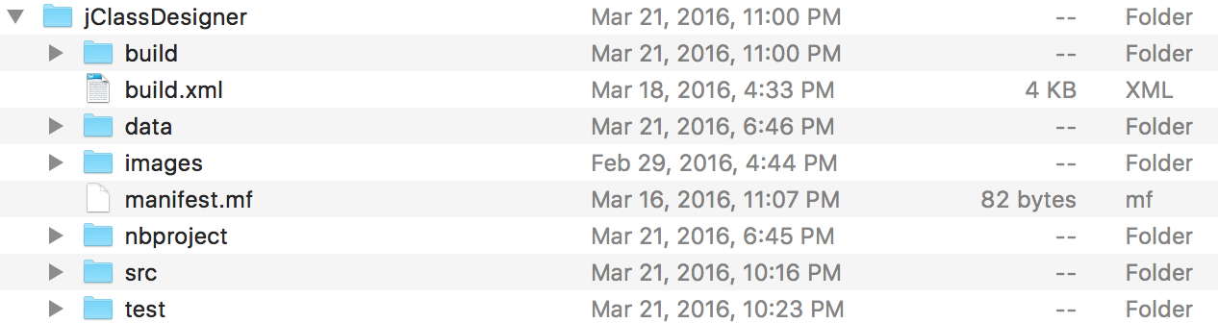

**Figure 5.1: jClass Designer File Structure**

The jcd.json provides all the class diagrams and variable/method names for each of the class diagram in the application. The file is a json file that can be used to describe a class diagram, each with their own variables and methods as follows:

**ClassPrototype:**

**{**

**"Fill":"0xffffffff",**

**"Stroke":"0xffff00ff",**

**“Name”: “Class/Interface1”,**

**“Package”: “Designer1”,**

**"Flag":0,**

**"X":247.0,**

**"Y":126.0,**

**"Width":369.0,**

**"Height":220.0,**

**“Parent”: 2,**

**“Parent_Name”: “Parent1”,**

**“Variables”: “Hello1”,**

**“Methods”: “Method1”,**

**},**

We can describe these values as follows:

**Fill –** a color used to fill the rectangle diagram of each ClassPrototype in the application. Must be implemented so that the rectangle is filled and not hollow. Will always be white.

**Stroke** – a color used to color the outline of the rectangle diagram of each ClassPrototype. Will always be black.

**Name** – a String used to name each individual ClassPrototype.

**Package** – a String used to define what package the current ClassPrototype belongs with.

**Flag** – an int to tell the application if the current ClassPrototype is a class or an interface. A ‘0’ is used to represent a class, and a ‘1’ is used to represent an interface.

**X** – a double that sets the location of the ClassPrototype by its X value.

**Y** – a double that sets the location of the ClassPrototype by its Y value.

**Width** – a double that sets the size of the rectangle ClassPrototype diagram by its width.

**Height** – a double that sets the size of the rectangle ClassPrototype diagram by its height.

**Parent** – an int that sets how many parents the ClassPrototype has. For a class diagram, a class could only have one parent class but could have multiple parent interfaces.

**Parent_Name** – a String used to name of the parent of the current ClassPrototype.

**Variables** – the name of the variables used by the ClassPrototype.

**Methods** – the name of the methods used by the ClassPrototype.

**6. Supporting Information**

Note that this document should serve as a reference for those implementing the code, so we’ll provide a table of contents to help quickly find important sections.

**6.1 Table of Contents**

1. Introduction

1. Purpose 2

2. Scope 2

3. Definitions, acronyms, and abbreviations 3

4. References 3

5. Overview 4

2. Package-Level Design Viewpoint 4

1. The jClass Designer and AppFramework Overview 4

2. Java API Usage 6

3. Java API Usage Descriptions 6

3. Class-Level Design Viewpoint 9

4. Method-Level Design Viewpoint 16

5. File Structure and Formats 27

6. Supporting Information 29

1. Table of contents 29

2. Appendixes 30

**6.2 Appendixes**

N/A